**STUDENT REGISTRATION**

**1. When we open the application, we can see the home page. There is a 'New Registration' button for new registrations. Click on the button.**



**2. After clicking, another window will open. Select 'student' on this window.**

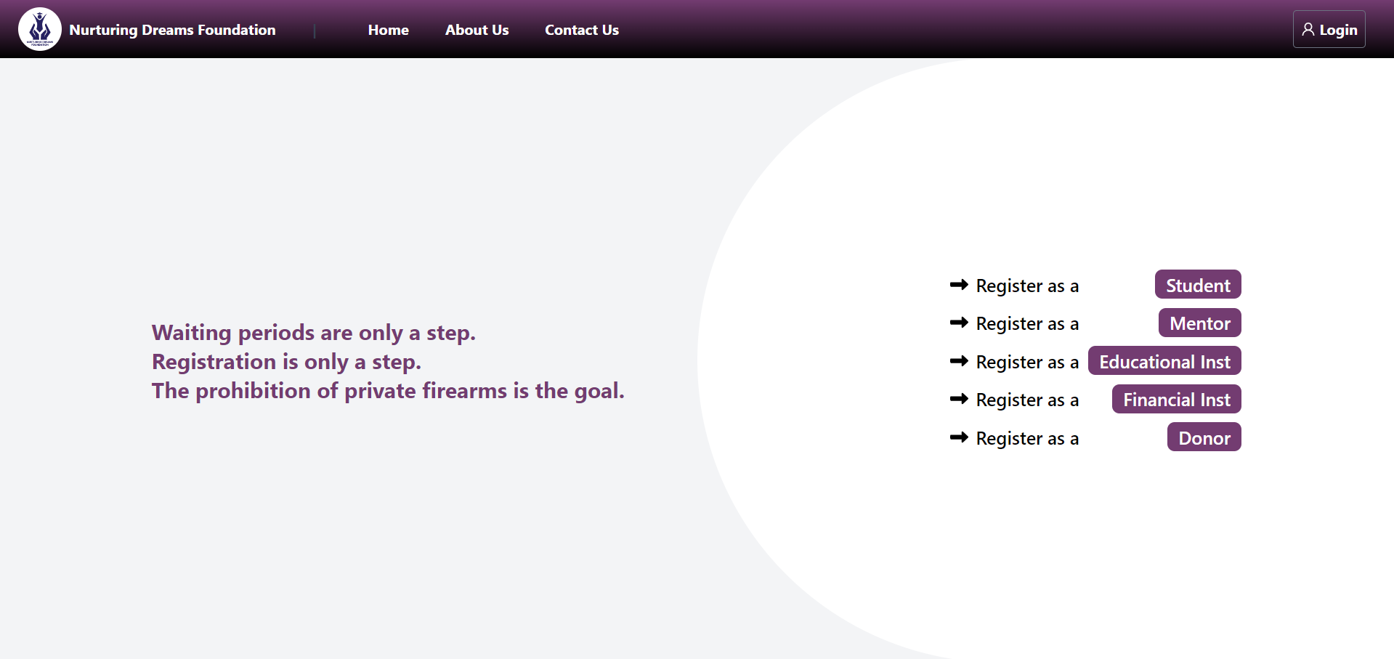

**3. All fields should be filled out as they are mandatory.**

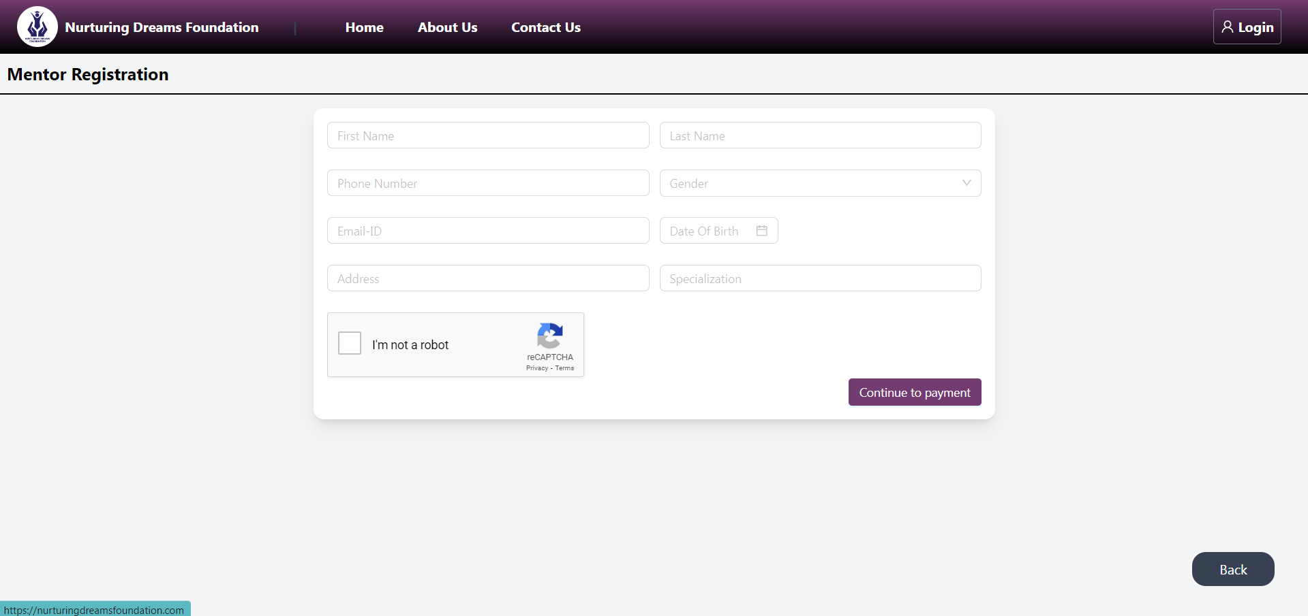

**4. This is a sample example. After filling out all the fields, press the 'Continue Payment' button.**

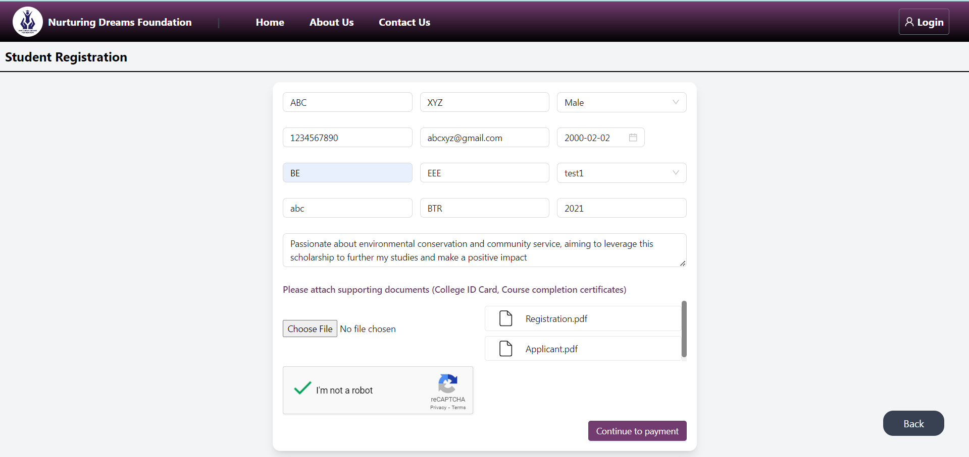

**5. Make the payment by clicking the 'Pay Now' option. Note: After a successful payment, you will complete your application process. If your payment is not successful, your application will not be complete. If the payment is unsuccessful, please continue from the beginning.**

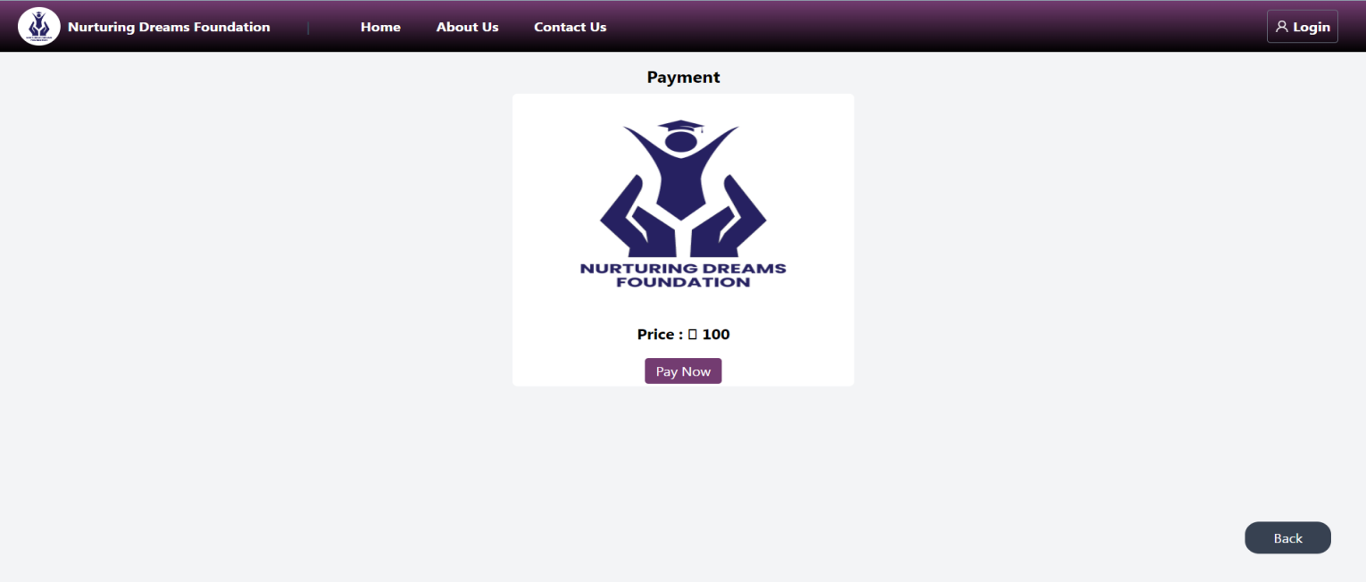

**6. This is the successful payment image.**

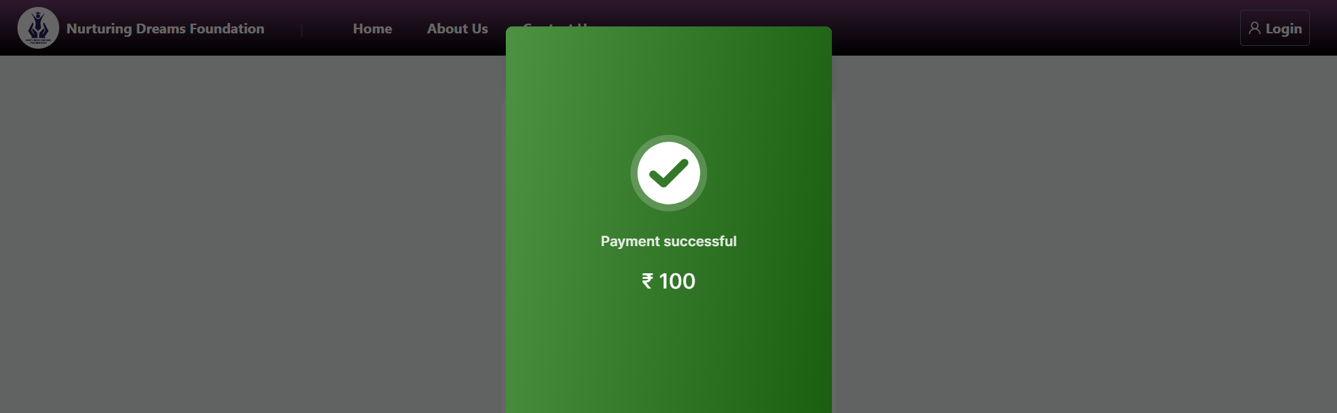

**7. After successful registration, you will see this type of window, and you will also receive a confirmation email.**

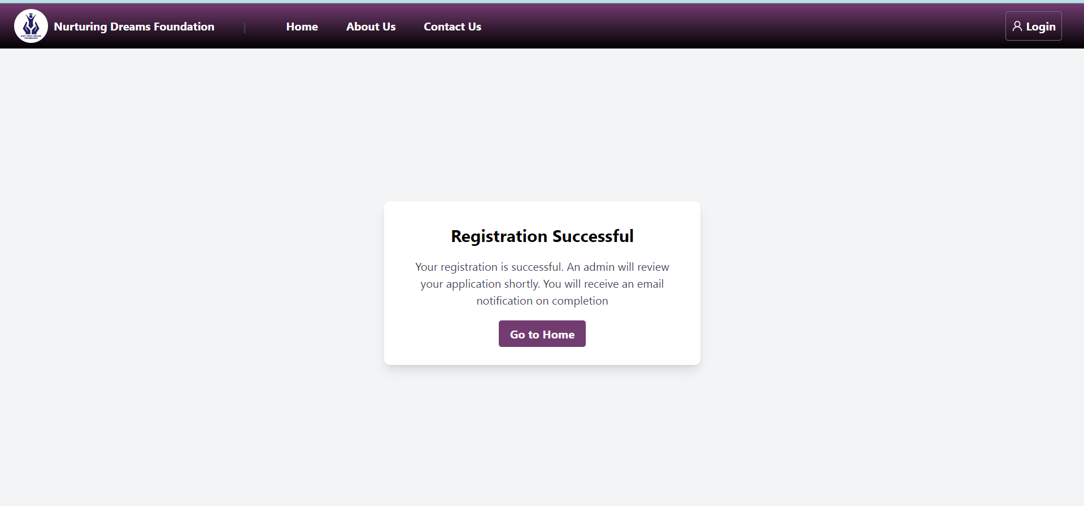

**8. This is a sample confirmation email.**

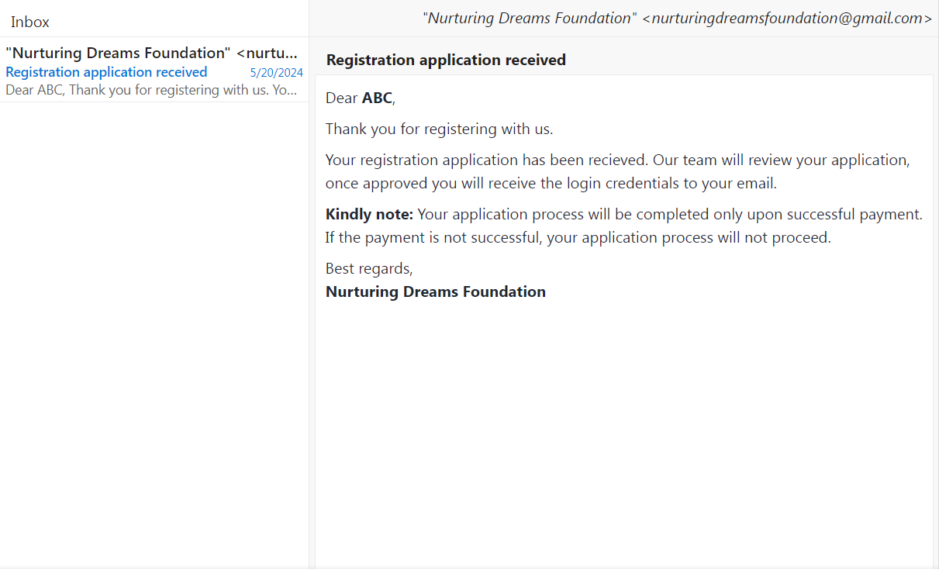

**9. If your application is rejected or put on hold, you will receive this type of email notification.**

**🡪 Reject**

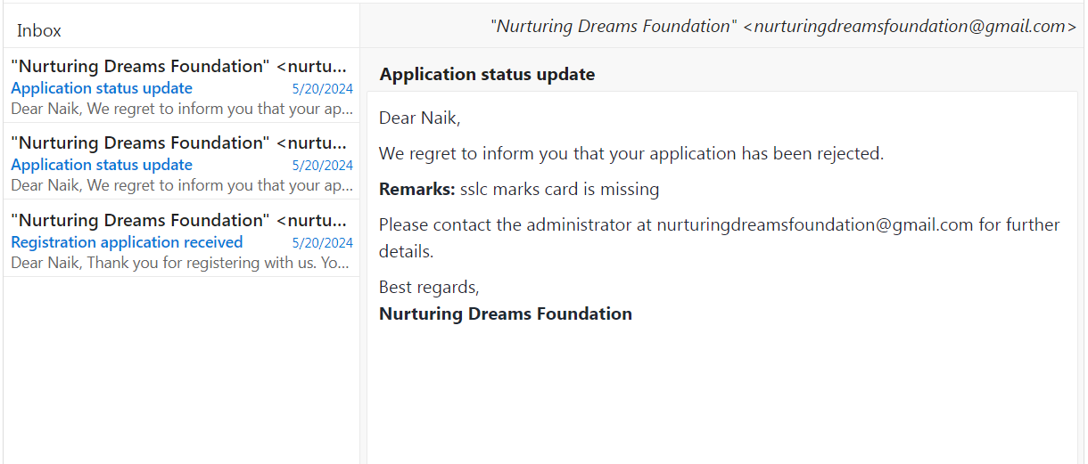

* **Hold**

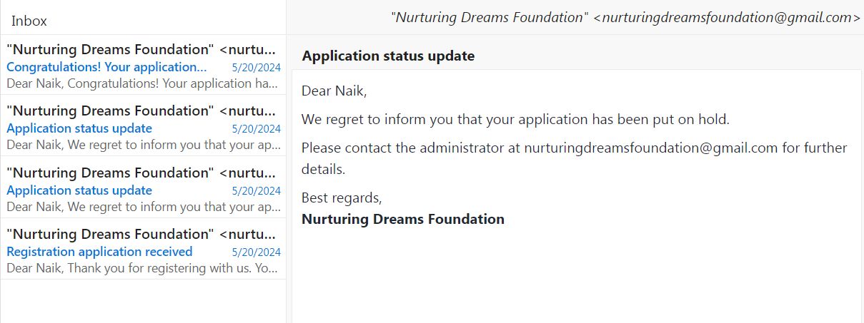

**10. If approved by the admin, you will receive login credentials via email. The below image is a sample email.**

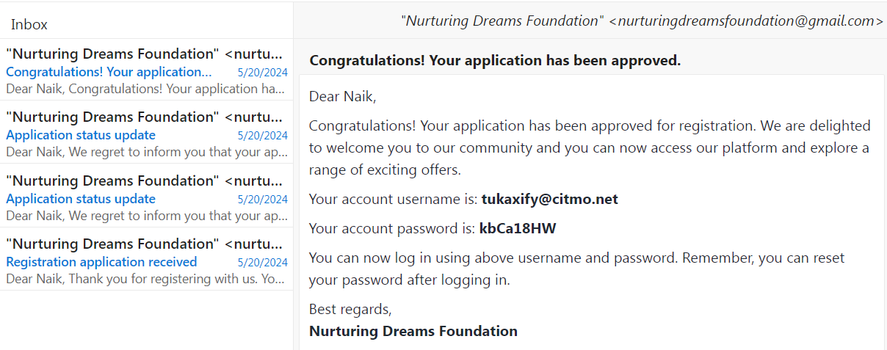

**11. Use the credentials to log in to the application.**

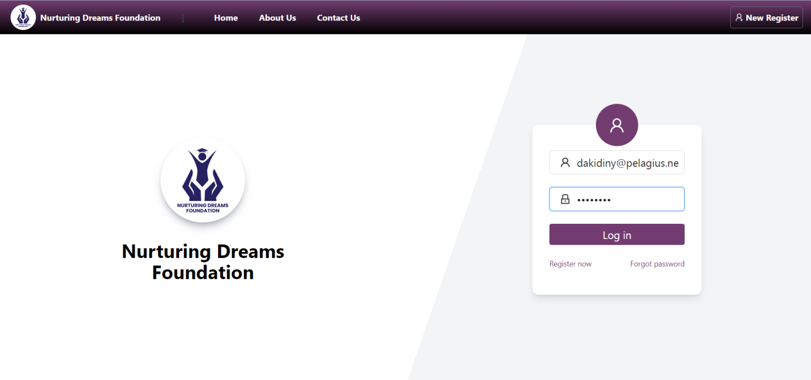

**12. This is the dashboard. Here you will get all the counts of your scholarship and loan applications.**

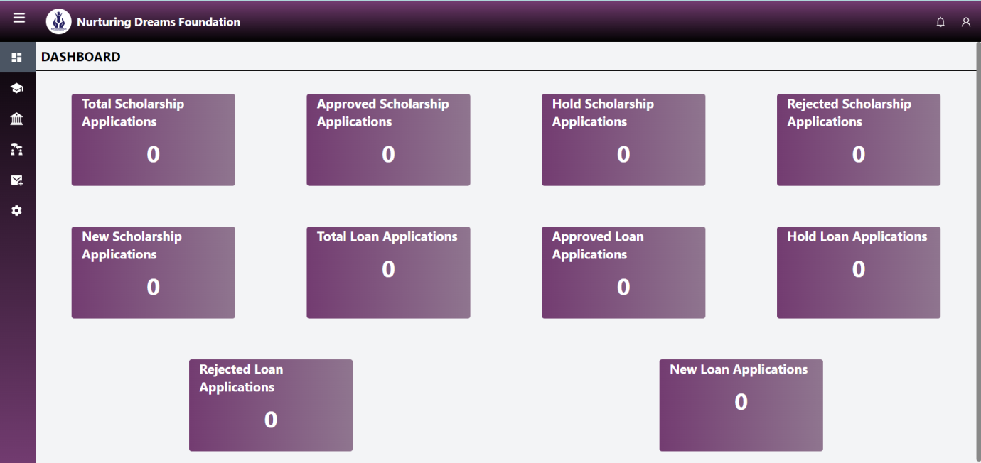

**13. This is the scholarship window where you can apply for scholarships by clicking the 'Apply for Scholarship' button. Here you can see all the scholarship application statuses.**

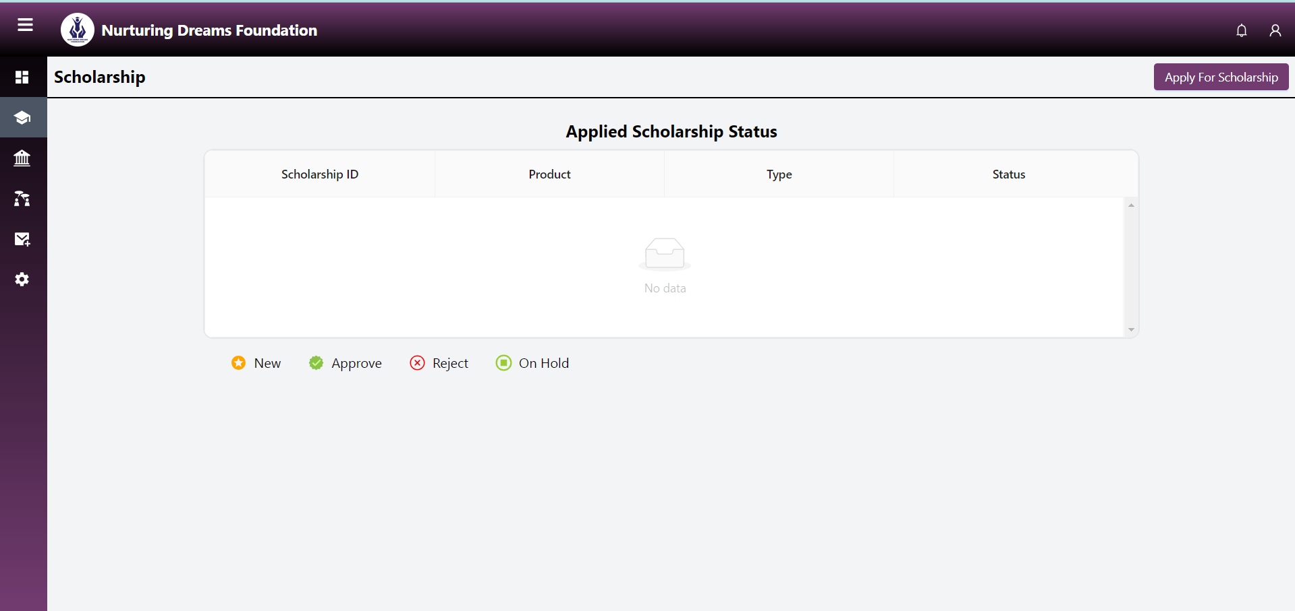

**14. Here you can apply for scholarships. The 'Scholarship Name' and 'Scholarship Purpose' will be available in the drop-down menu.**

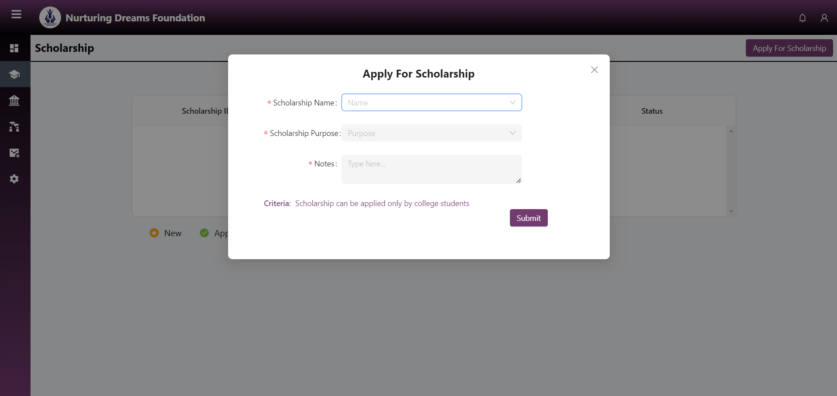

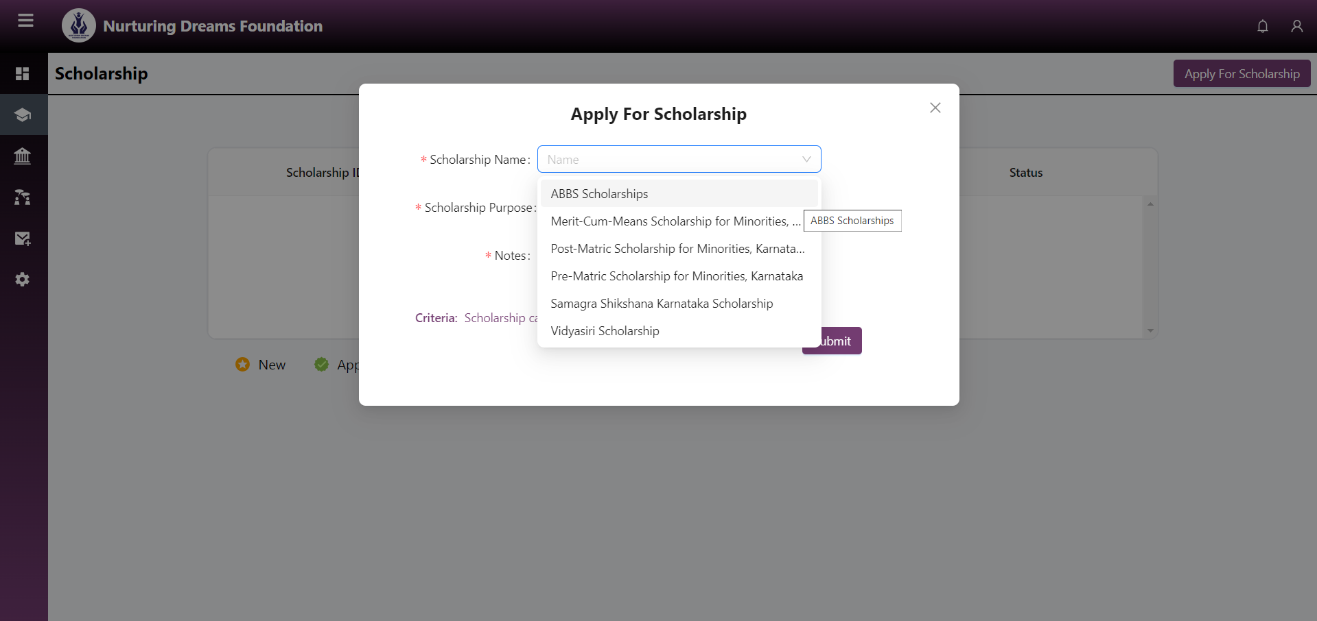

**15. After selecting the 'Scholarship Name', you will get a 'View' option. You can view the file with information about the scholarship.**

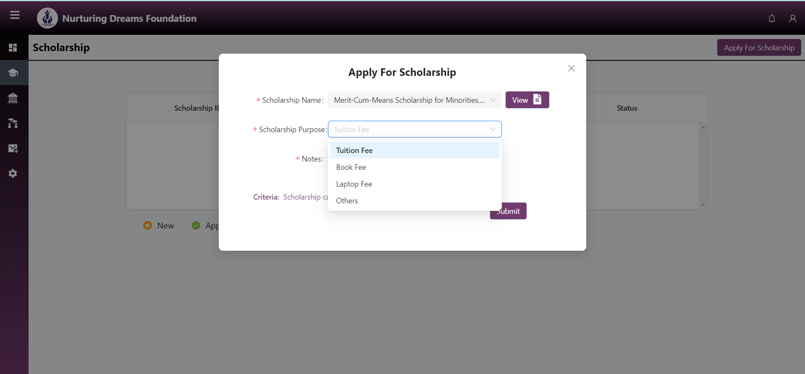

**16. After filling out everything, click on the 'Submit' button.**

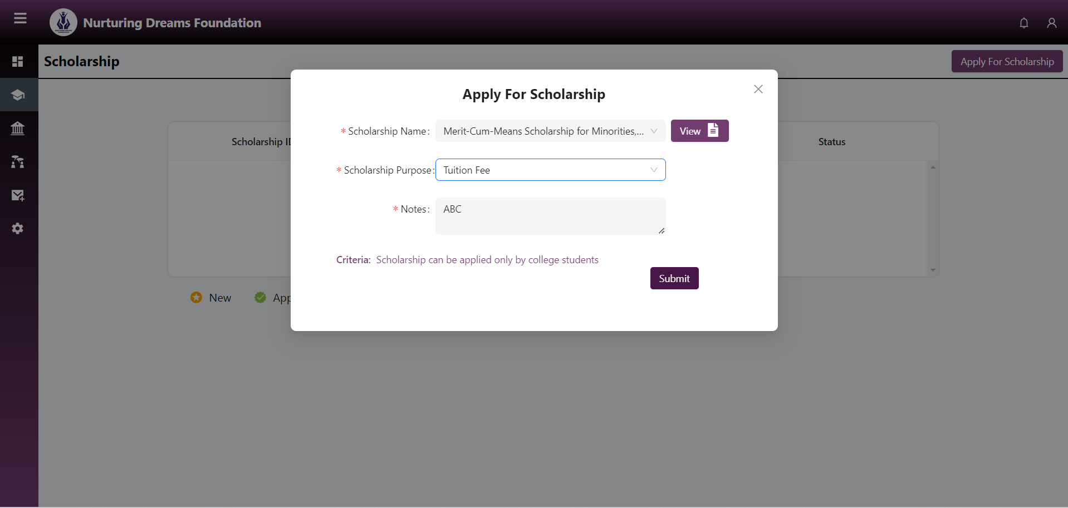

**17. After submitting, you will get the application ID in a pop-up window and also receive a confirmation email. Here, you will get the status of scholarship applications with status and name.**

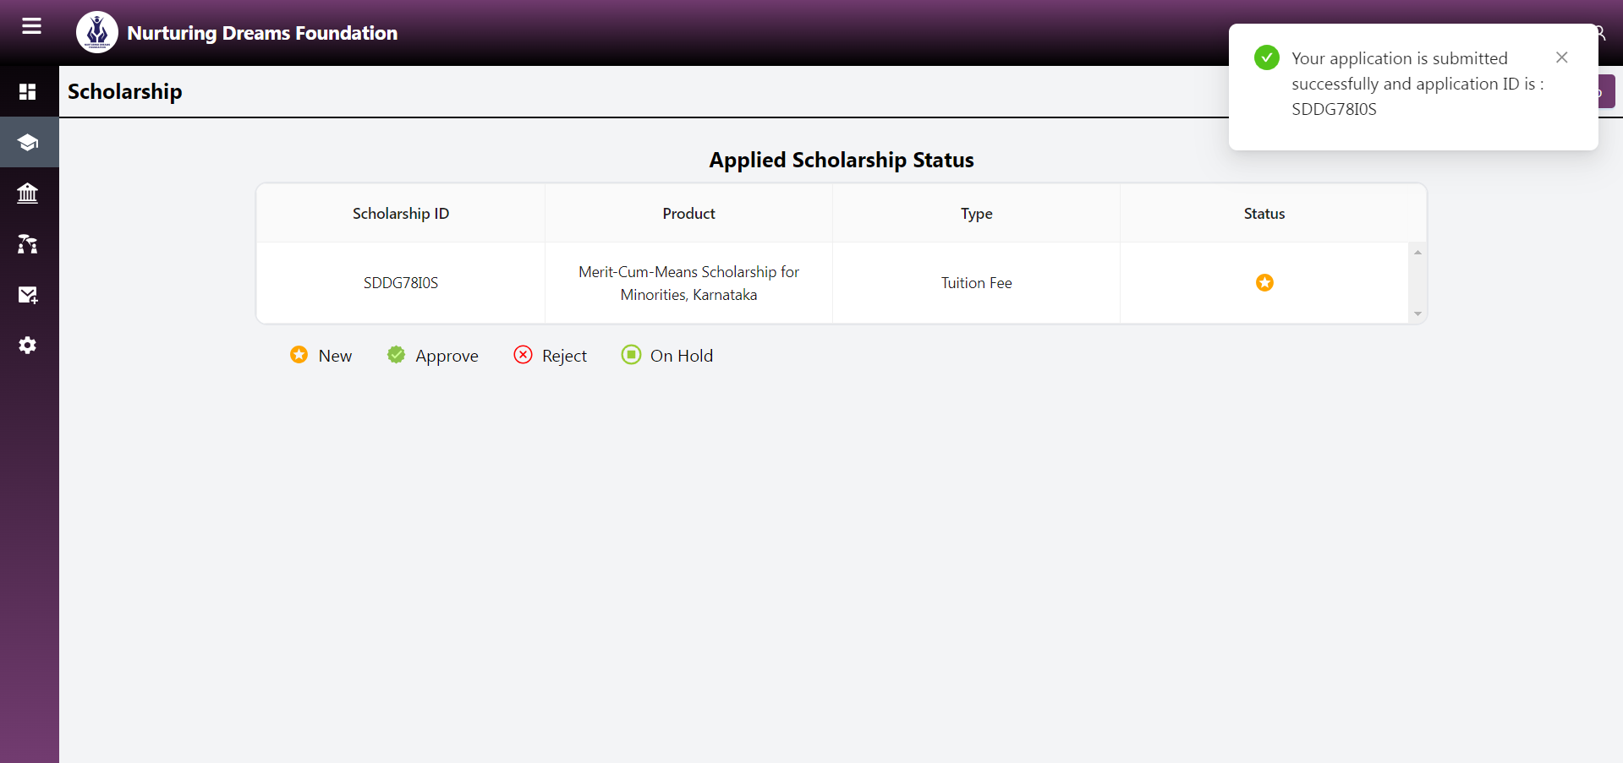

**18. The loan application process is the same as the scholarship application process.**

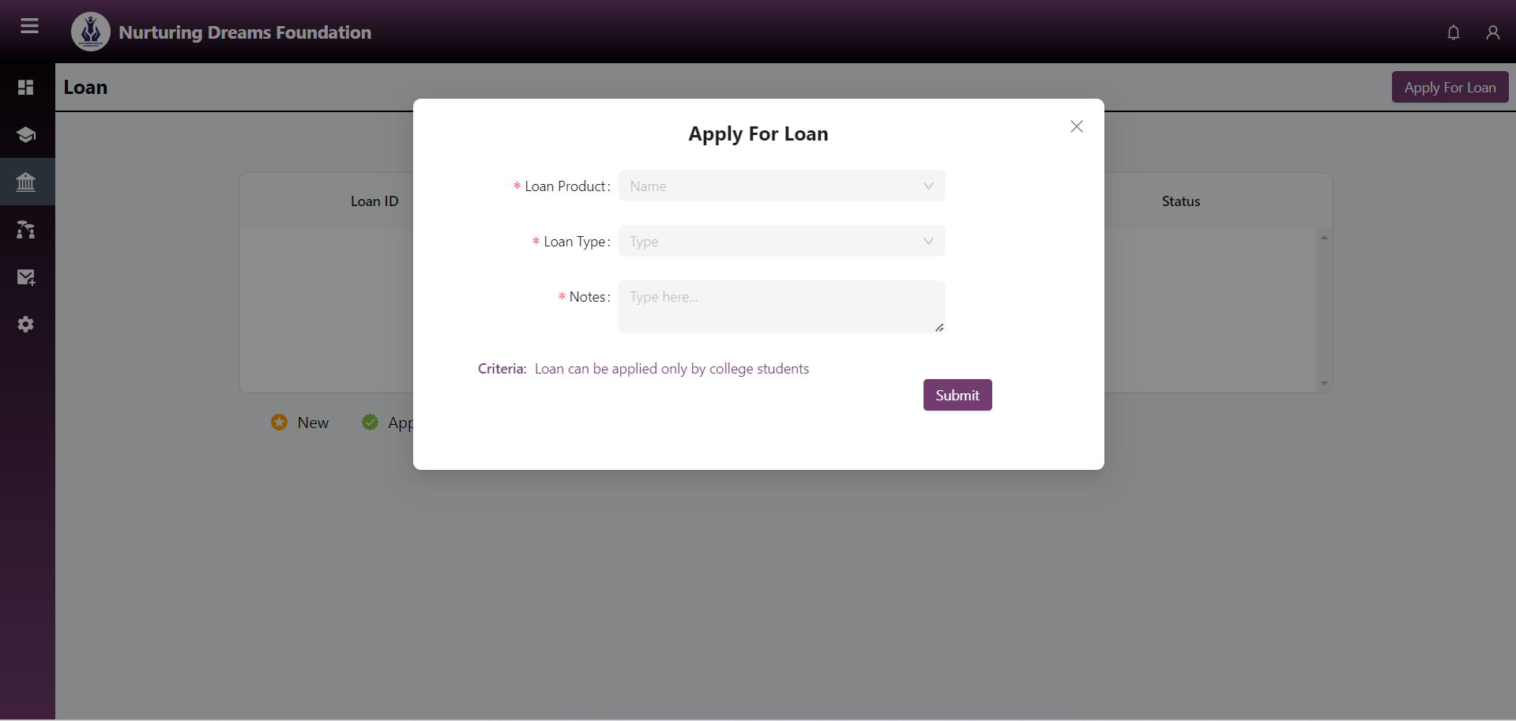

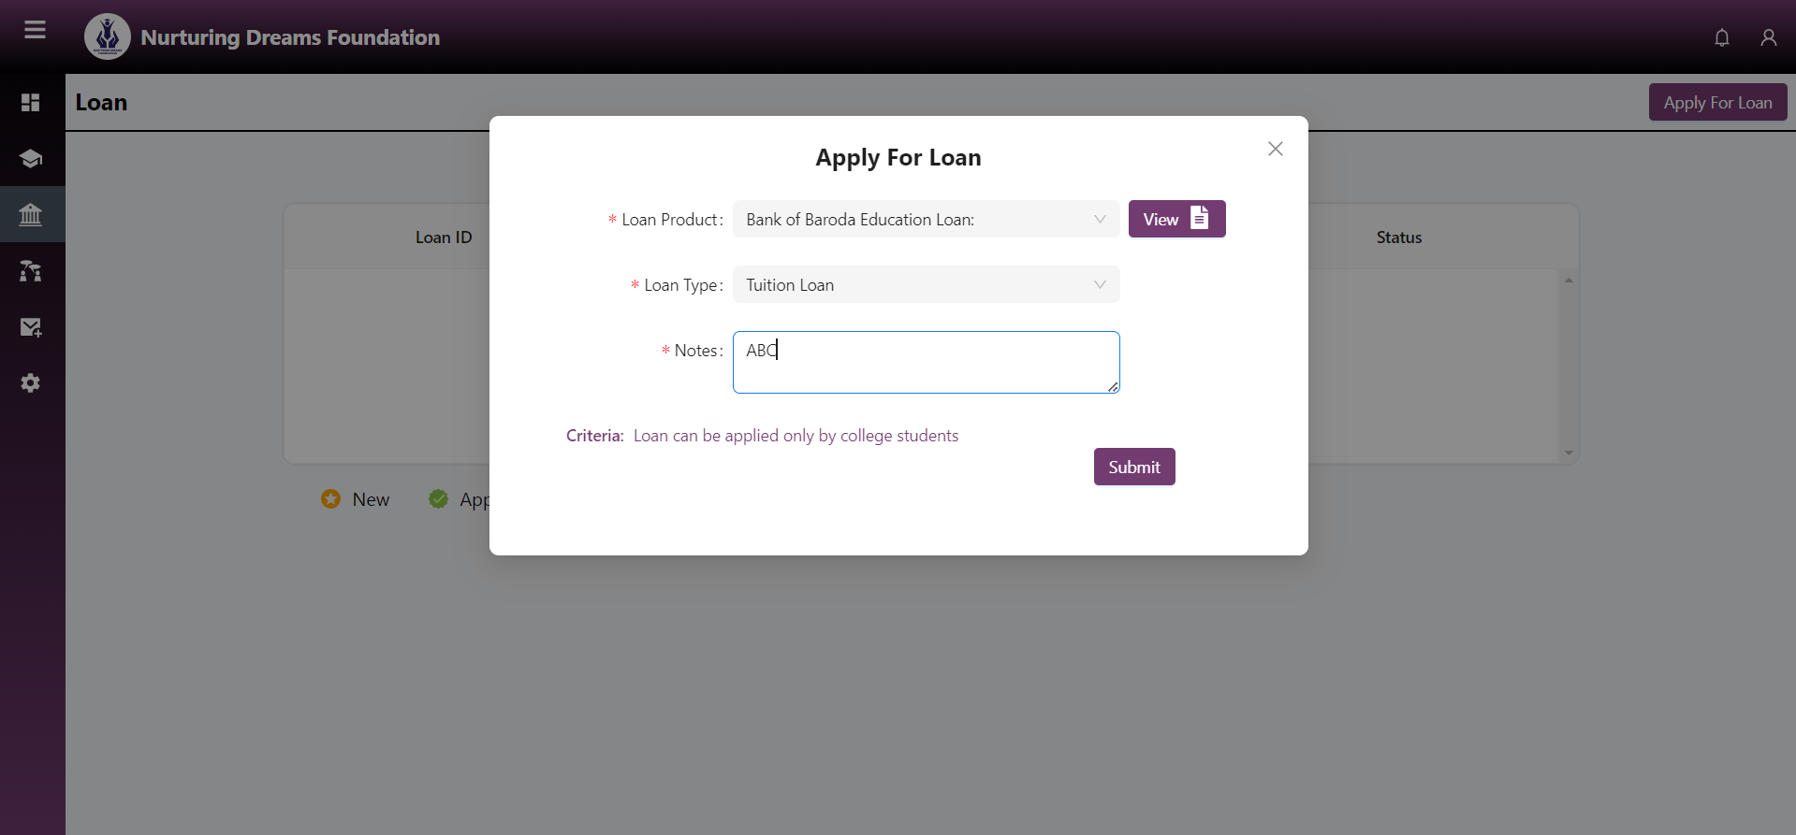

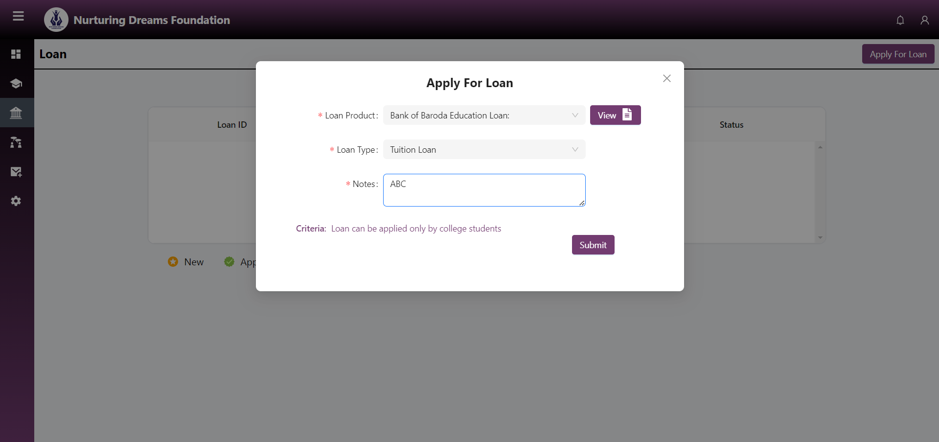

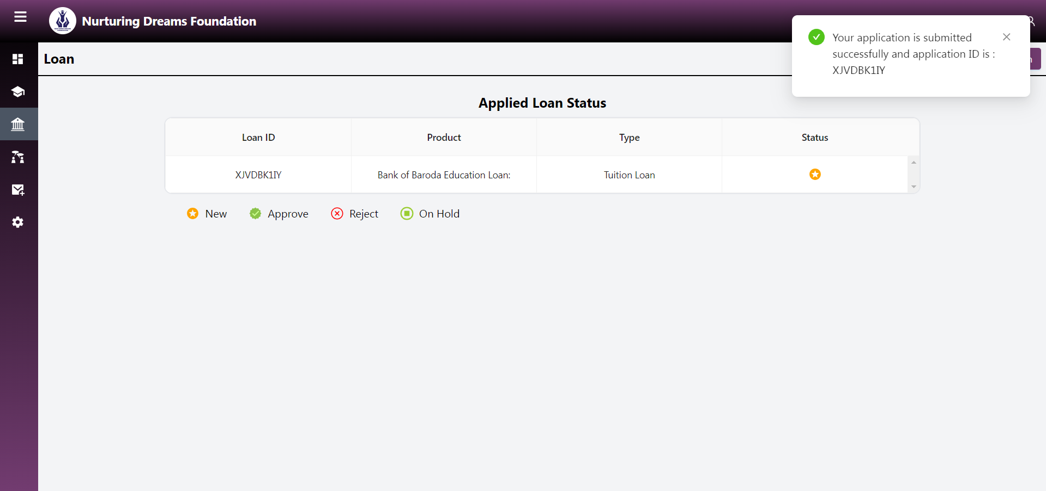

**19. After the scholarship and loan application, you will receive an email confirmation.**

**🡪 For scholarship**

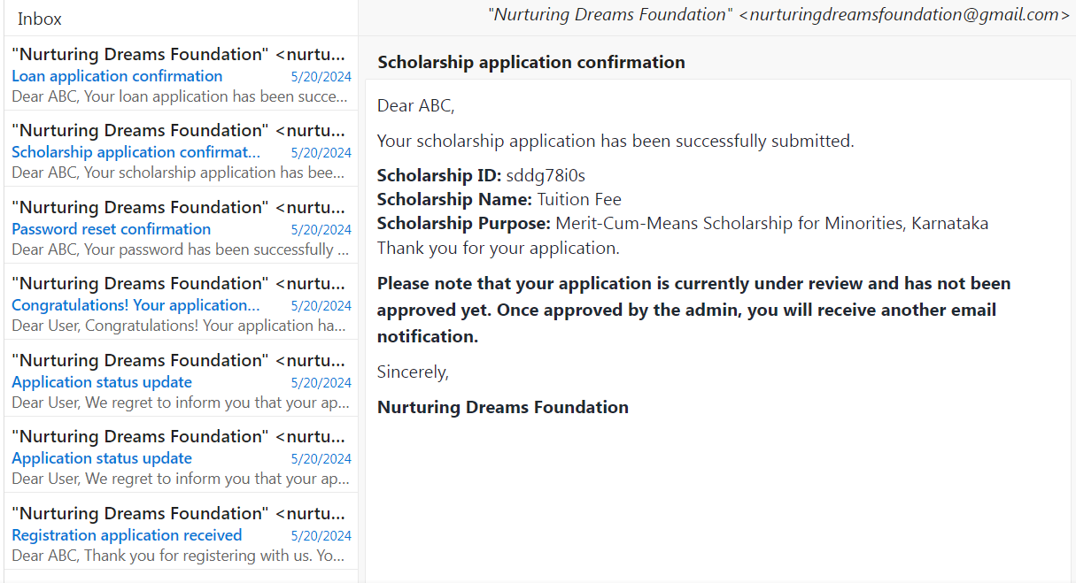

**🡪For loan**

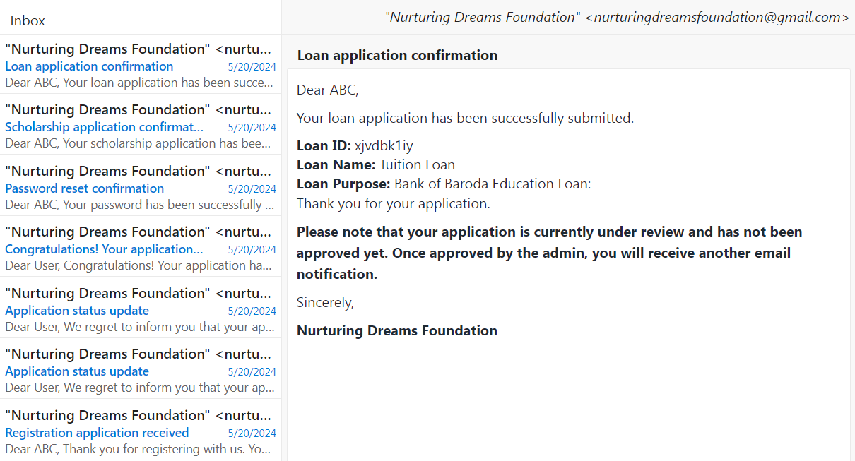

**20. After the admin approves your scholarship or loan, you will get an email notification.**

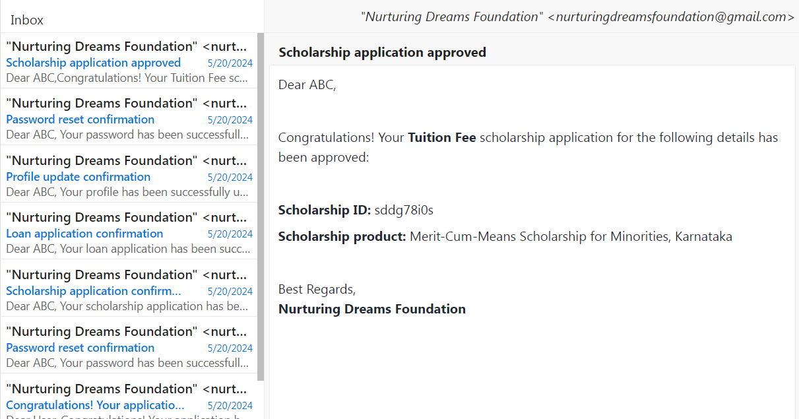

**21. This is the discussion forum. Select any forum and start a discussion with everyone.**

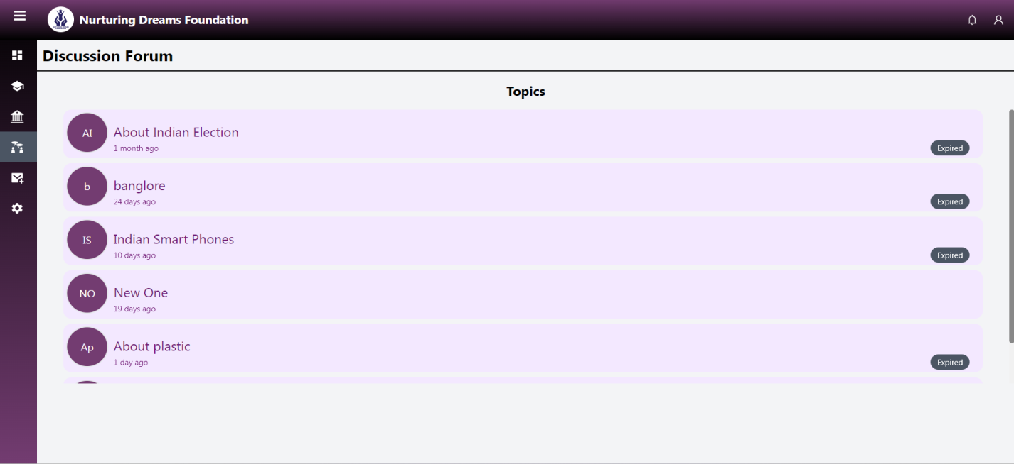

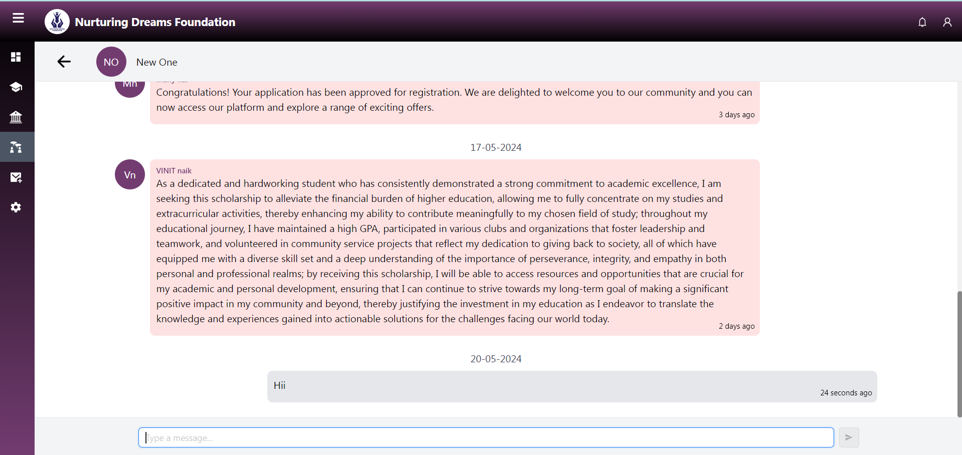

**22. Here you can chat with a mentor. By clicking the search box, you will get a list of mentor names. Select the mentor and start chatting.**

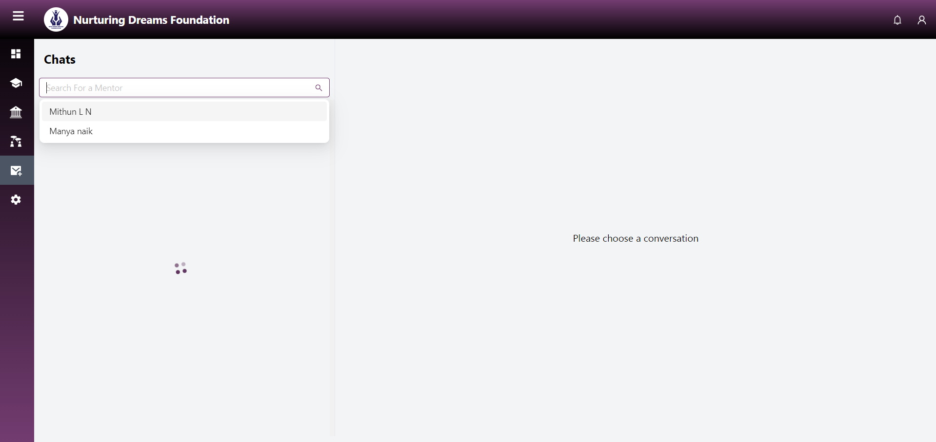

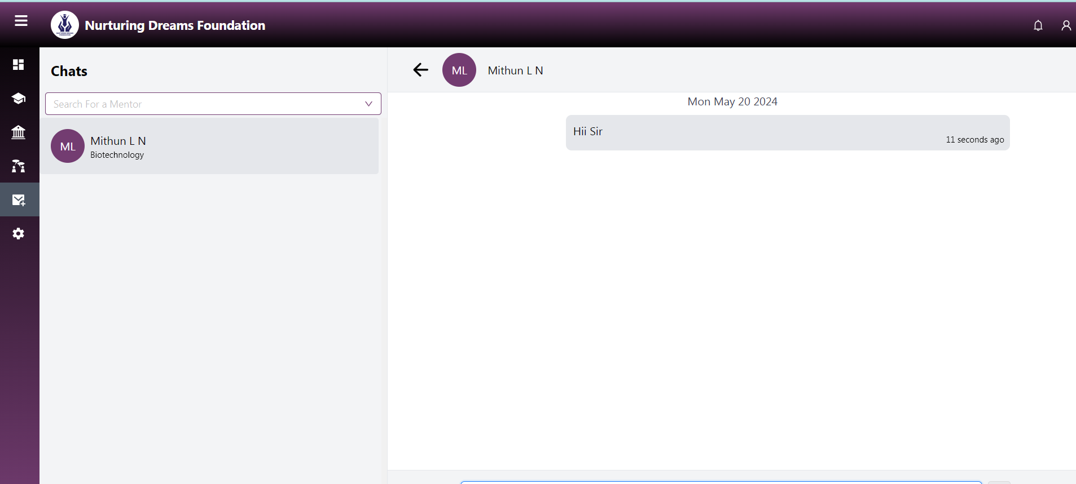

**23. Here you can reset your password and update your profile.**

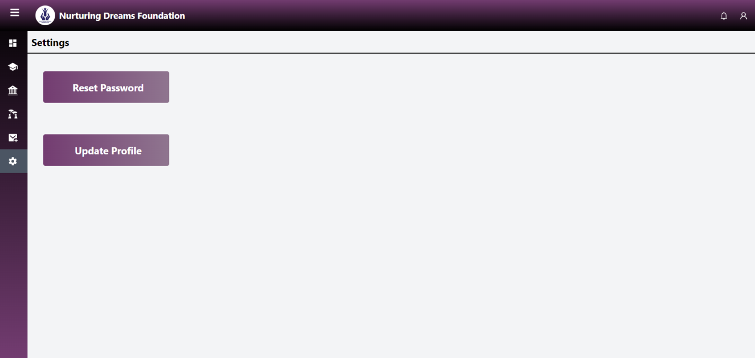

* **Reset password**

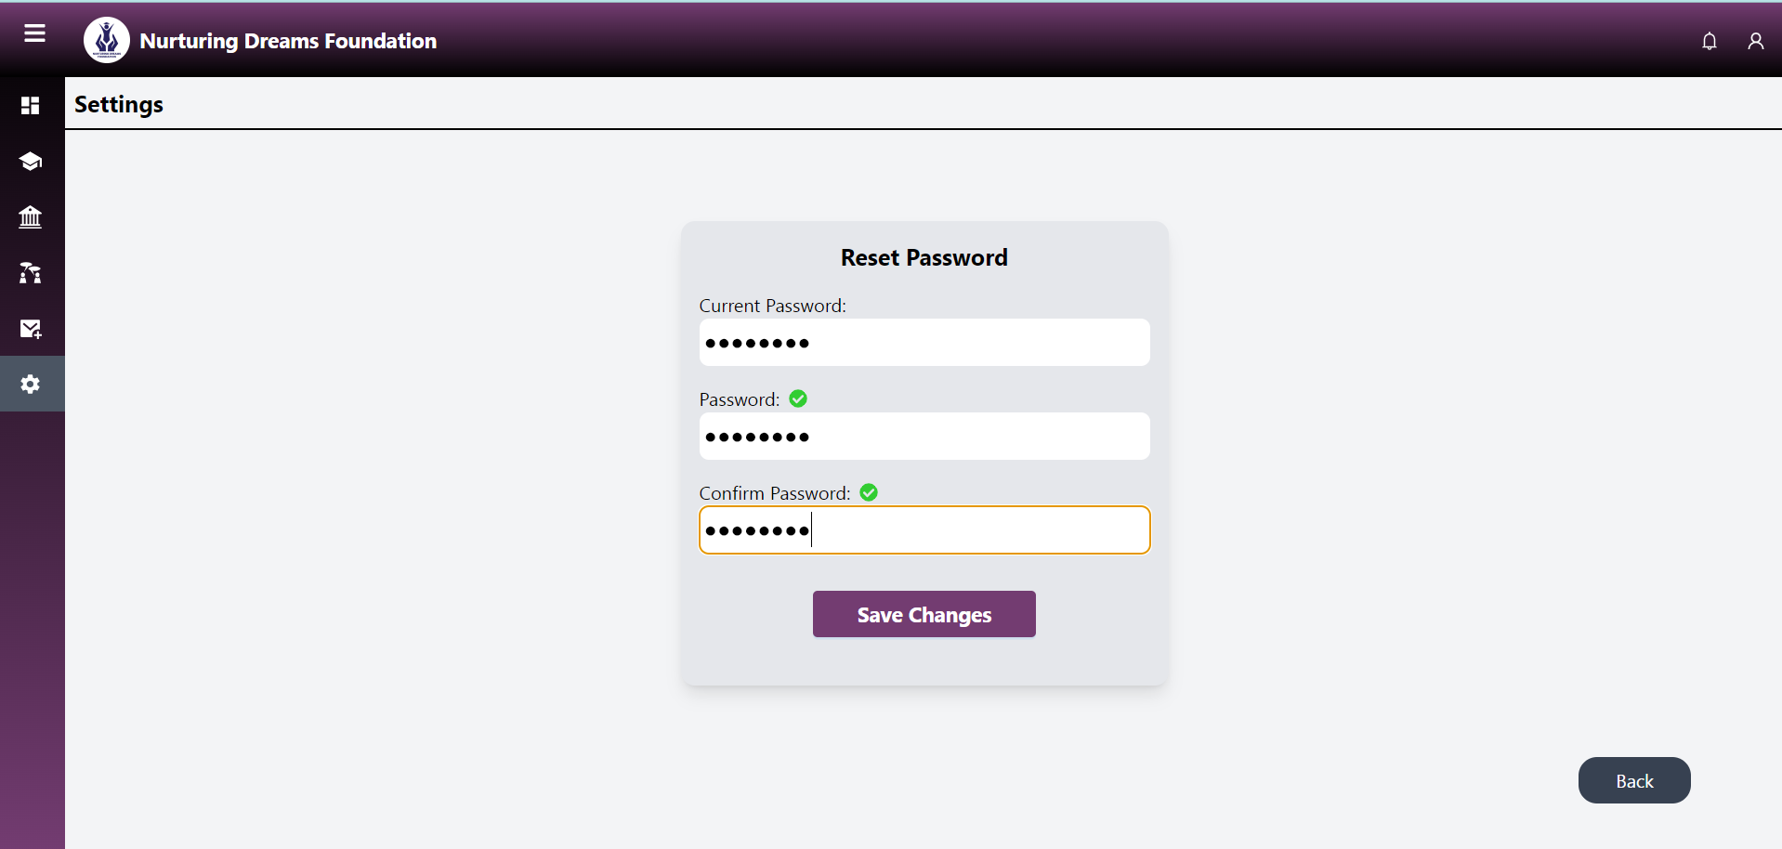

* **Profile update**

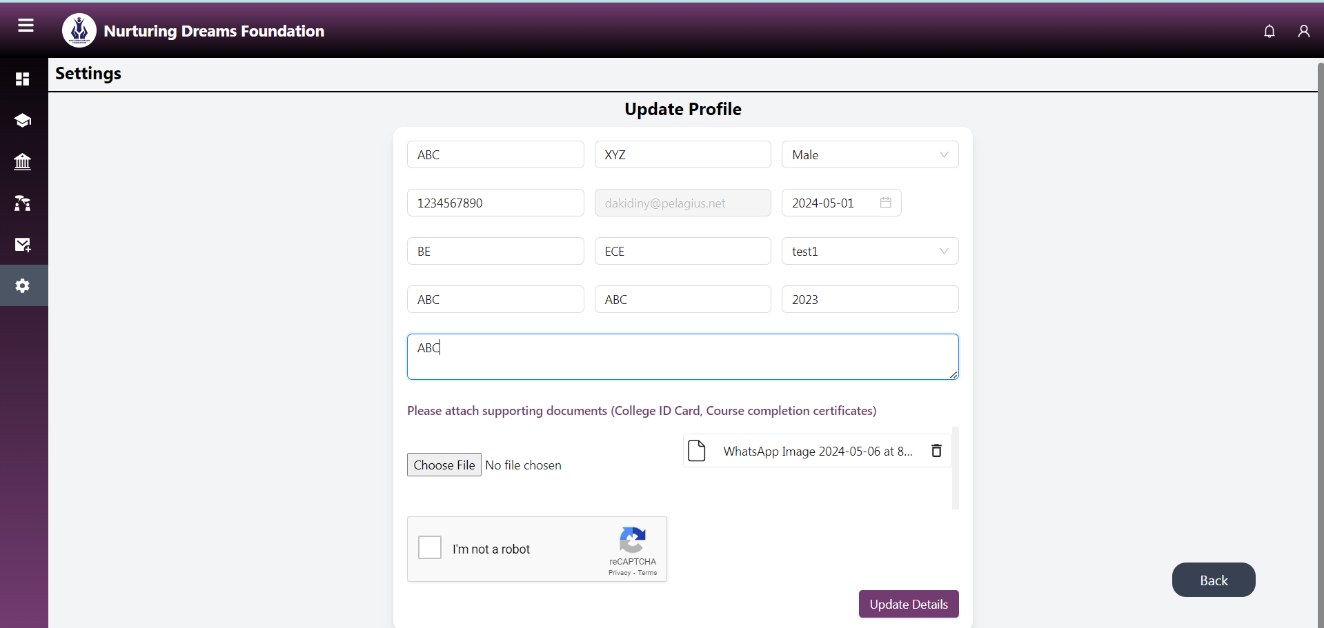

**24. After resetting and updating the profile, you will get an email notification of the confirmation.**

**🡪 Profile update**

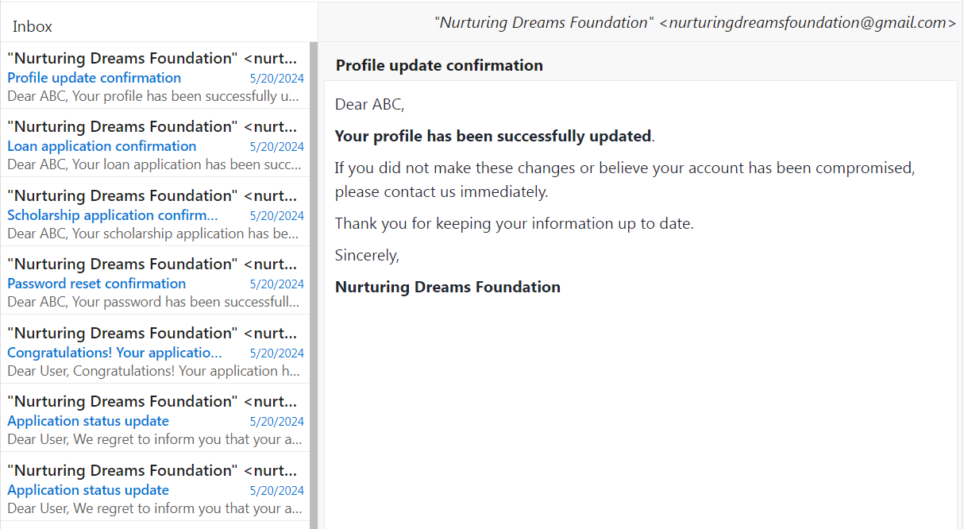

* **Reset password**

